**Exp. No : 4**

**User Defined Function (UDF) in PIG**

1. Create sample.txt

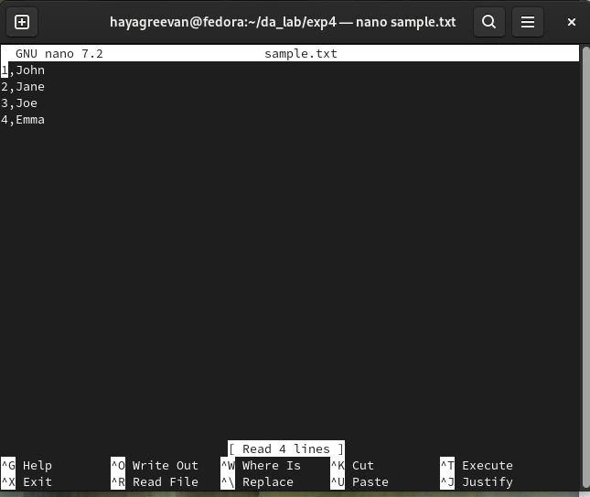

1. Upload sample.txt file to HDFS Storage.



1. Create demo_pig.pig file

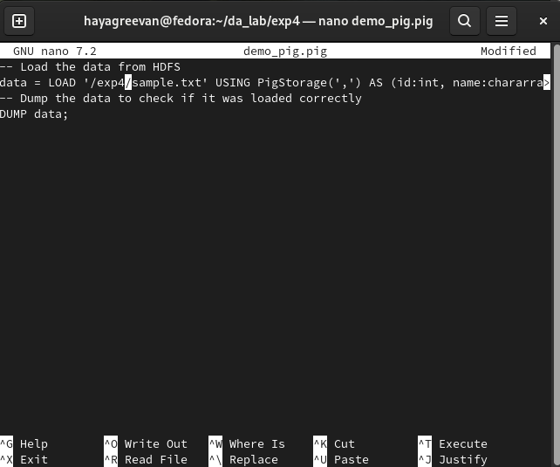

1. Execute demo_pig.pig

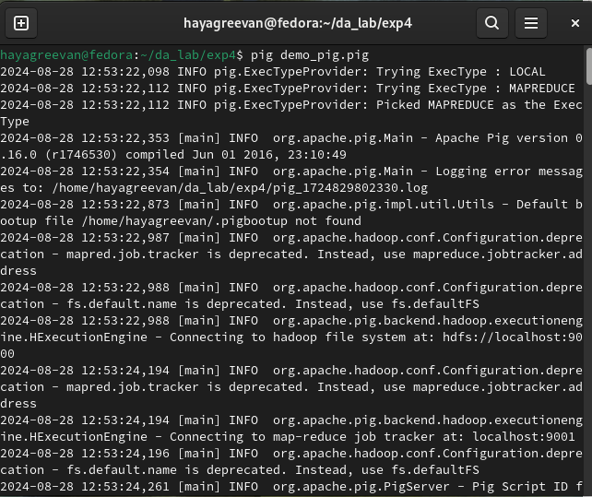

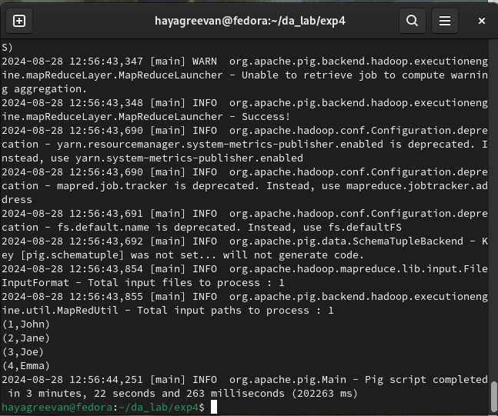

1. Create uppercase_udf.py

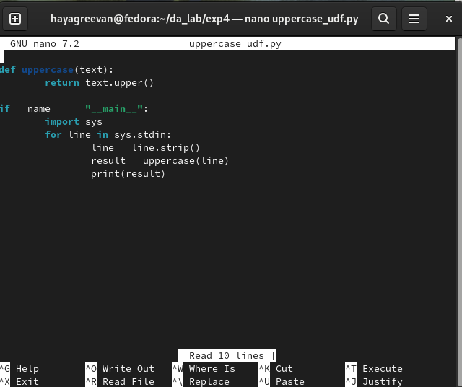

1. Upload uppercase_udf.py file to HDFS Storage.



1. Create udf_example.pig

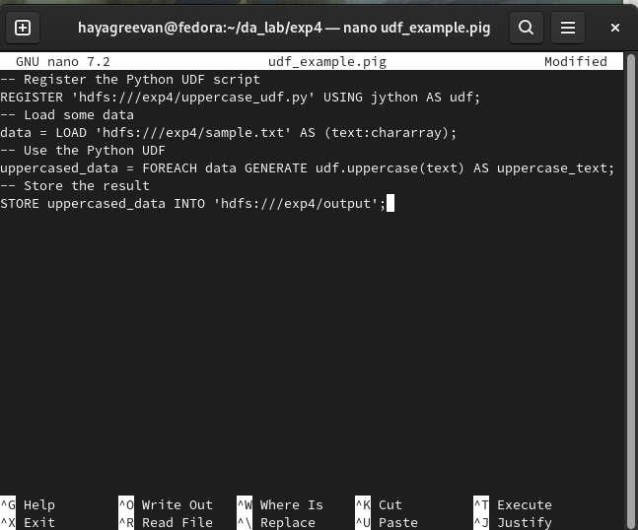

1. Execute udf_example.pig

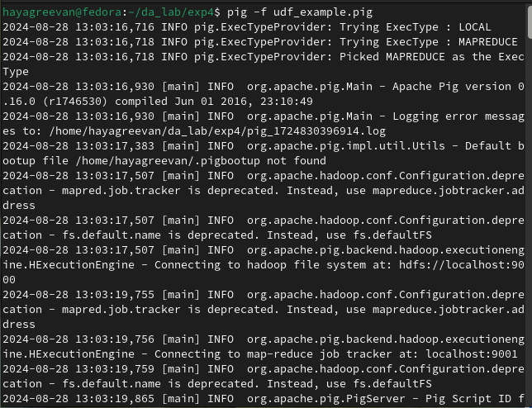

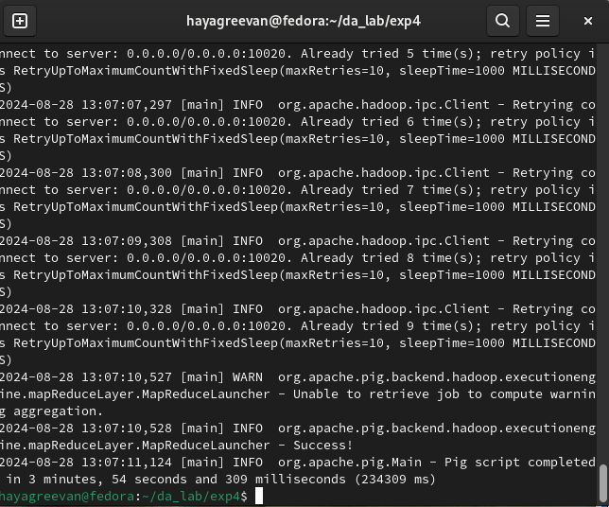

**Output :**

